MAT 243 Project Three Summary Report

Karver Stockstill
Karver.stockstill@snhu.edu
Southern New Hampshire University

This summary report examines the data sets related to NBA wins, including the average points scored, average relative skill, average point differential and average relative differential between teams. Predicting the number of total wins that a team can achieve during the regular season from this data. The management along with the coaches have requested regression models looking into predicting total number of wins in a regular game based on the performance metrics that they have included in the data set provided. Using statistical analysis methods of simple linear/multiple regression alongside correlations and scatterplots to provide prediction analysis. I hope that the analysis provided will give management and coaches proper information to prepare the team for a successful upcoming season.
This analysis report will use the Python programming language alongside important variables to obtain the predictions desired. ‘Total_wins’ indicates the number of wins during the regular season. The variable ‘avg_pts_differential’ represents the average point differential between the team and their opponent. This is important in understanding overall team performance, measuring the difference in scored in relation to what they allow their opponents to score. The variable ‘avg_elo_n’ represents average relative skill of each team in a regular season. The measure of relative skill is based on the final score of the game, the game location, the outcome of the game in relative to the probability of that outcome.
Data visualizations help to interpret data to show relationships between variables. From data visualizations we can interpret were problem areas occur and what needs to be work on or improved upon to obtain the desired result. Allowing management and coaches to visually interpret complex data sets and understand patterns, trends, and correlations that can improve the team.
Correlation coefficient helps in understanding the relationship of two variables based on the strength and direction associated between them. If one variable increases as the other increases then there is a positive correlation. Oppositely as one variable increases when the other variable decreases there is a negative correlation. The correlation coefficient has ranges that help to indicate the strength: 0 – 0.40 indicates a weak correlation, 0.40 – 0.80 indicates a moderate correlation and 0.80 – 1 indicates a strong correlation.
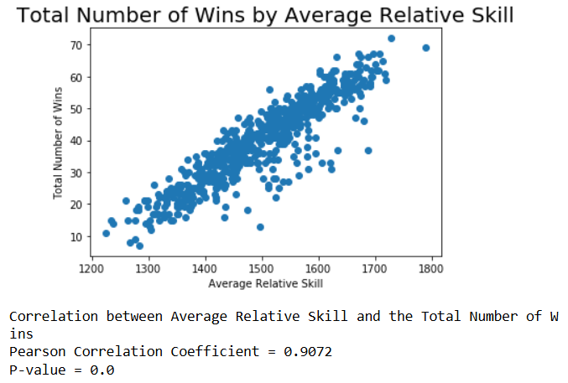
Scatter plot above shows an increasing linear effect in relation to average skill and total number of wins, drawing a line through this scatter plot would give us a positive slope . Understanding as one variable increases the other variable does as well, concluding that as the relative skill increases the total number of games won also increases.
The Pearson correlation coefficient is 0.9072, remarkably close to 1 which signifies a strong correlation. When using a level of significance (denoted by α) of 1% or 0.01in relation to our p-value of 0.0 we can conclude since the p-value is lower than 0.01 that there is considerable evidence between the total numbers of wins and the average relative skill.
Simple linear regression model is a statistical method that gives us information to summarize and study relationships between two continuous variables by using a line drawn to create a positive or negative regression line. There is typically a response variable and predictor variable(s) involved. The response variable refers to the variable measured in an experiment, anticipated to vary according to changes in the predictor variable(s). The predictor variable(s) are the modified or adjusted variables used to examine their effect on the response variable (GeekforGeeks, 2025).
The standard equation for linear regression is Y = β0 + β1(x) +β2(x)…..βn(x) where β0 indicates the response variable and β1 and so forth are the predictor variables.
The equation for this model with having only one predictor variable is: Y= -128.2475 + 0.1121(x1)
The null hypothesis for this model is that no relation will exist between the predictor variable and the response variable. The alternative hypothesis for this model is that a relationship does in fact exist between the response variable and the predictor variable.
Mathematically:
Null hypothesis: H0: β1 = 0
Alternative hypothesis: Ha: β1 ≠ 0
Level of significance: α = 5% or 0.05 which tells us the p-value must be < 0.05 to reject the null hypothesis.
Table 1: Hypothesis Test for the Overall F-Test

Statistic | Value
Test Statistic | 2865.00
P-value | 8.06e-243

The overall F-test conducted determines if there was a significant linear relationship between total wins and the average relative skill of a team throughout the season. The p-value rounded is 8.06e-243 which is significantly lower than the level of significance 0.05 which shows that there is considerable evidence between the average relative skill and the total number of wins.
A predicted total number of wins in a regular season for a team that has an average relative skill of 1550 would be: -128.2475 + 0.1121(1550) = 45.5075 giving us a total of 46 wins.
A predicted total number of wins in a regular season for a team that has an average relative skill of 1450 would be: -128.2475 + 0.1121(1450) = 34.2975 giving us a total of 34 wins. From these equations we can easily see how the relative skill directly affects the total number of wins that occur throughout the season.
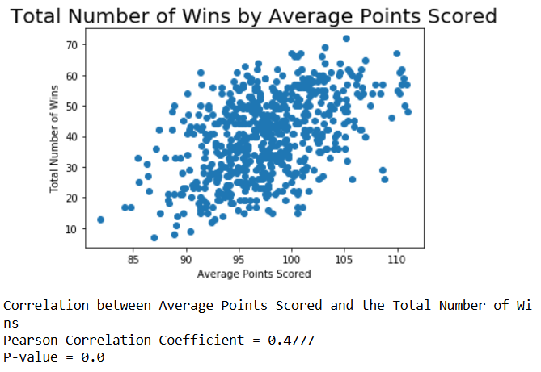
The scatter plot above shows the correlation and relationship of the average points scored to the total number of wins achieved. From this scatter plot we can see a positive relationship between the two, signifying that a team with a higher average points scored is more likely they are to have a higher total number of wins within the season. As stated previously the correlation range is (0 - 0.40), (0.40 - .080), (0.80 – 1) with the correlation growing in strength as the range increases. The Pearson correlation coefficient is 0.4777 which puts it in the middle range that signifies a moderately strong correlation. Upon examining the graph, this conclusion appears warranted; although a positive relationship exists, it is less pronounced than observed in previous instances. When comparing the p-value of 0.0 to the level of significance of 1% or 0.01, the p-value is lower than 0.01 signifying that there is considerable evidence in the average points scored with the total number of wins.
Multiple linear regression analysis is a statistical method used to determine the relationships between one or more predictor variables and one response variable.
The equation for this model with two predictor variables is: Y= -152.5736 + 0.3497(x1) + 0.1055(x2)
The null hypothesis for this model indicates that predictor variables are all equal to zero. The alternative hypothesis for this model is that at least one of the predictor variables does not equal zero.
Mathematically:
Null hypothesis: H0: β1 = β2 = 0
Alternative hypothesis: Ha: βi ≠ 0 for i = 1,2
Level of significance: α = 5% or 0.05 which tells us the p-value must be < 0.05 to reject the null hypothesis.
Table 2: Hypothesis Test for the Overall F-Test

Statistic | Value
Test Statistic | 1580.00
P-value | 4.41e-243

The p-value is 4.41e-243 which when rounded is 0.00, comparing it to the level of significance of 0.05 we can see that the p-value is lower. This concludes that we can reject the null hypothesis and conclude that there is a relationship between at least one of the predictor variables and the total number of wins.
The individual t-test for average relative skill is 0.1055 with a p-value of 0.000 and using a significance level of 1% or 0.01 the p-value is lower signifying that this is considerable evidence that the average relative skill is in relation to the total wins throughout the season. Comparatively the individual t-test for the average points is 0.3497 with a p-value of 0.000 and using a significance level of 1% or 0.01. The p-value is lower concluding that there is considerable evidence with average points in relation to total wins throughout the season.
The predicted total number of wins in a regular season for a team that is averaging 75 points per games with a relative skill of 1350 is: -152.5736 + 0.3497(75) + 0.1055(1350) = 16.0789 rounding to a total of 16 wins
The predicted total number of wins in a regular season for a team that is averaging 100 points per game with an average relative skill level of 1600 is: -152.5736 + 0.3497(100) +0.1055(1600) = 51.1964 rounding to a total of 51 wins
The coefficient of determination denoted by R-squared is .837 or 84%. This tells us that 84% of the data fits the model we are using.
Multiple linear regression analysis is a statistical method used to determine the relationships between one or more predictor variables and one response variable. With multiple regression models you can continuously add predictor variables to see how they will directly affect the response variable.
The equation for this model with two predictor variables is: Y= 34.5753+ 0.2597(x1) - 0.0134(x2) + 1.6206(x3) + 0.0525(x4)
The null hypothesis for this multiple regression model indicates that predictor variables are all equal to zero, showing no significant correlation. The alternative hypothesis for this model is that at least one of the predictor variables does not equal zero and does show a significant correlation.
Mathematically:
Null hypothesis: H0: β1 = β2 = β3 = β4 = 0
Alternative hypothesis: Ha: βi ≠ 0 for i = 1,2,3,4
Level of significance: α = 5% or 0.05 which tells us the p-value must be < 0.05 to reject the null hypothesis.
Table 3: Hypothesis Test for Overall F-Test

Statistic | Value
Test Statistic | 1102.00
P-value | 3.07e-278

The p-value is 3.07e-278 rounded makes it 0.000, in relation to the significance level of 0.05 the p-value is less than. With the p-value < 0.05 we can reject the null hypothesis.
The overall F-test conducted to determine if there was a significant linear relationship between total wins and any of the predictor variables used; average points scored, average relative skill, average point differential and average relative differential. Conducting this test will help to understand if any or all these predictor variables are significant in relation to the total wins from a team within the NBA season.
The multiple linear regression show that the predictor variables of average points scored, average relative skill, average point differential and average relative differential all have significant factors in influencing the total wins of a team during the NBA season. The individual t-tests in relation to a 1% or 0.01 significance levels are:
Average points scored: 6.070 with p-value of 0.000, the p-value is less than the level of significance 0.01 indicating that this predictor variable is significant regarding total wins.
Average relative skill: -0.769 with p-value of 0.442, the p-value is above the level of significance 0.01 indicating that this predictor variable is not significant regarding total wins.

Average point differential: 12.024 with p-value of 0.00, the p-value is less than the level of significance 0.01 indicating that this predictor variable is significant regarding total wins.
Average relative differential: 2.915 with p-value of 0.004, the p-value is less than the level of significance 0.01 indicating that this predictor variable is significant regarding total wins.
The coefficient determination obtained from the overall F-test which denoted as R-squared is 0.878 interpreted at 88%, which tells us that 88% of the data used fits in model we are using.
The predicted total number of wins in a regular season for a team that is averaging 75 points per game with a relative skill level of 1350, average point differential of -5 and average relative skill differential of -30 is:
Y= 34.5753+ 0.2597(75) - 0.0134(1350) + 1.6206(-5) + 0.0525(-30) = 26.2848 rounding to a total of 26 wins during the NBA season.

The predicted total number of wins in a regular season for a team that is averaging 100 points per game with a relative skill level of 1600, average point differential of +5 and average relative skill differential of +95 is:
Y= 34.5753+ 0.2597(100) - 0.0134(1600) + 1.6206(5) + 0.0525(95) = 52.1958 rounding to a total of 52 wins during the NBA season.
In conclusion Total number of games won significantly impacts average points scored, average relative skill, average point differential and average relative differential. Teams that have higher values in those areas will win more games in the future seasons than teams with lower values.
The response variable ‘total_wins’ for a team during the NBA season showed a direct response to the predictor variables used throughout this statistical analysis. Showing a strong positive linear regression that average relative skill impacts total wins. As we included additional predictor variables in relation to the response variable of total wins, it became apparent that multiple factors contribute to a team's overall number of wins.
This summary report can help management and coaches understand that there is more than one variable needed to successfully create wins for their team. It is not just about the points scored in the game or the skill of the individual players; it is how they can use all those factors to bring the team together shaping them into a stronger unit. It is important to recognize that the prioritization and improvement of multiple factors all work toward achieving the highest possible win ratio. Building the players and management into an unstoppable force for the upcoming season.

Resources

GeeksforGeeks. (23 July, 2025). Explanatory and Response Variable.
https://www.geeksforgeeks.org/data-analysis/explanatory-and-response-variable/

